EBAY CONTROLLER TEST DATA SHEET

P/N: 414-8005 Date: 08/03/2018 Time: 14:04

S/N: 10 Tested by: Elie Talias

Hardware Rev: BLDC_60A_V6 Approved by: Elie Talias

Software Rev: 5.3.9

Equipments Used

Equipments Model No Serial No

Power Supply

Digital Multimeter

CAN Interface

Resistance Decade Box

PC

AHU-L (47) P/N 413-8005-1

AHU-R (63) P/N 413-8005-2

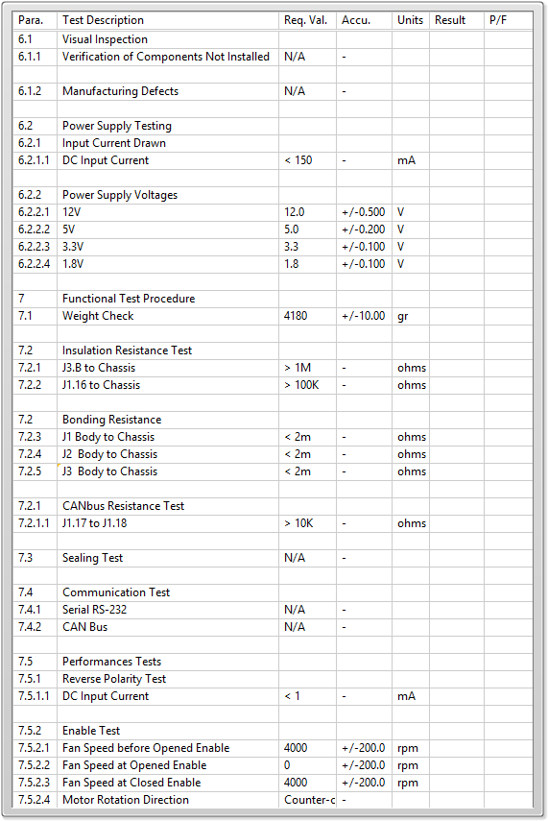

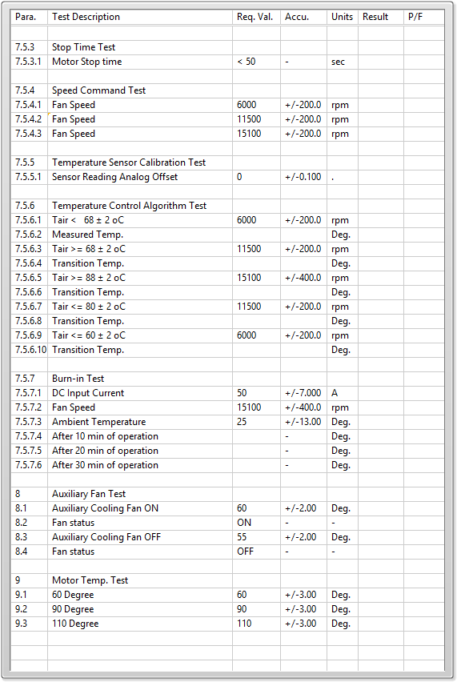

General result:

Test-Operator:____ Elie Talias_________ Q.A.:__________________________